Overview of the Moodle Course for “Cross-organizational distributed systems and Clouds”
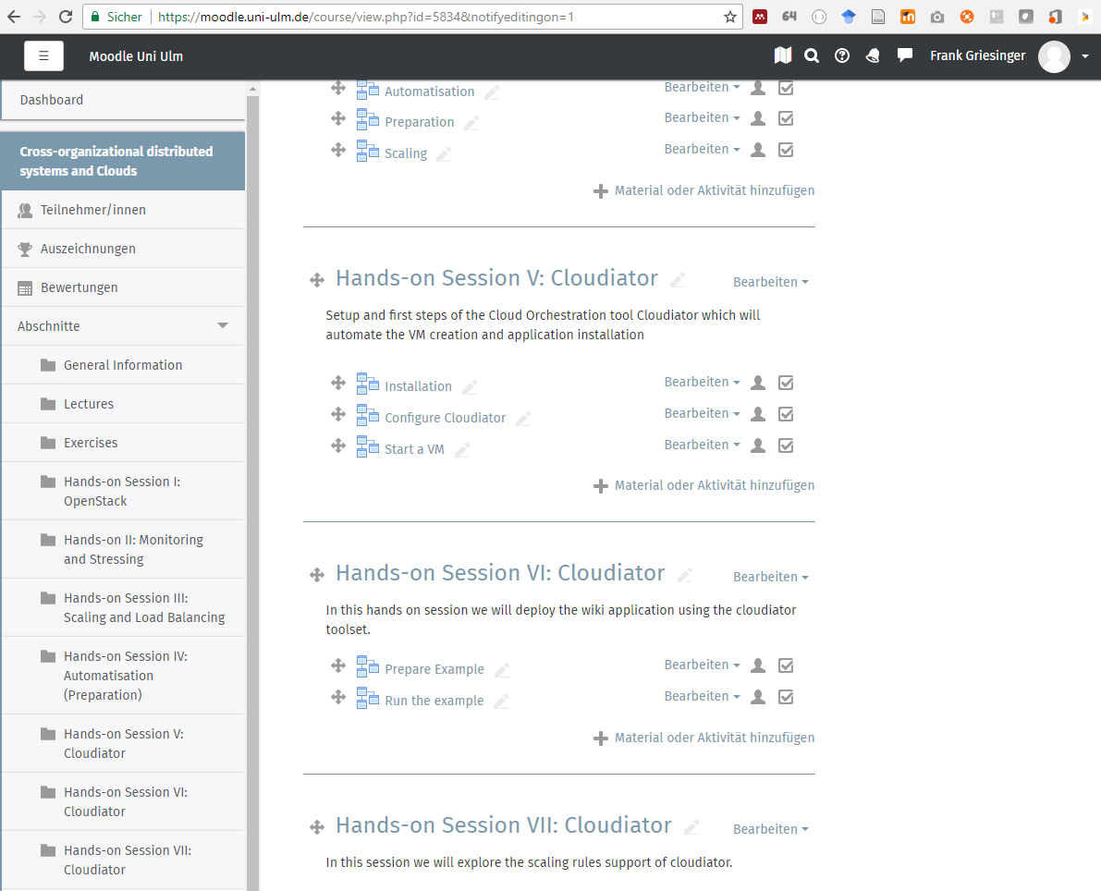

Screenshot of one of the Cloudiator-related excersises:
